AI-Powered Mystery Case Analysis and Investigation Assistant
Project Documentation
Submitted by:
Harini N – E25AI210
B.Sc. Computer Science (Artificial Intelligence)
Hemamalini S – E25AI215
B.Sc. Computer Science (Artificial Intelligence)
Jenita Roselin S – E25AI218
B.Sc. Computer Science (Artificial Intelligence)
Yuvashri H – E25AI240
B.Sc. Computer Science (Artificial Intelligence)
Platform: Dify AI Platform
Program: FacePrep Campus GenAI & LLM
1.Abstract :
Mystery Investigation AI is an AI-powered assistant designed to support mystery and investigation-related queries using Retrieval-Augmented Generation (RAG). The system uses a knowledge base containing investigation-related information and retrieves relevant content based on the user's query.
The retrieved information is then provided to an AI model, which analyzes the context and generates a clear and meaningful response. This approach helps provide knowledge-grounded answers instead of relying only on general AI knowledge.
The project is implemented using the Dify AI Platform, where Knowledge Retrieval and an AI node are connected through a workflow.
2.Introduction :
Mystery investigation involves analyzing different clues, suspects, statements, and case information. Finding relevant information from a large amount of investigation data can be time-consuming when done manually.
Mystery Investigation AI provides an AI-based solution for retrieving relevant investigation information and generating useful responses. By combining Knowledge Retrieval with an AI model, the system can understand the user's query, retrieve related information, and generate an appropriate answer.
The project demonstrates how Generative AI and RAG technology can be applied to an investigation-based use case.
3.Project Overview :
Mystery Investigation AI is developed as a RAG-based AI application using Dify.
The system consists of:
- User Input
- Investigation Knowledge Base
- Knowledge Retrieval
- Mystery Investigation AI
- Final Output
When a user enters an investigation-related question, the Knowledge Retrieval component searches the knowledge base for relevant information. The retrieved information is then passed to the AI model, which analyzes the context and generates the final response.
Basic Flow:
User Query → Knowledge Retrieval → Retrieved Knowledge → AI Analysis → Final Answer
4. Objectives :
The main objectives of the project are:
- To develop an AI-powered mystery investigation assistant.
- To use RAG for knowledge-grounded responses.
- To retrieve relevant information from an investigation knowledge base.
- To analyze clues and case-related information using AI.
- To provide clear and understandable responses.
- To reduce the time required to search investigation information.
- To demonstrate the practical use of Generative AI.
5. Problem Statement :
Traditional mystery investigation requires manually examining large amounts of case information, clues, statements, and evidence.
The major problems include:
- Searching through large documents is time-consuming.
- Relevant information may be difficult to locate.
- Manually connecting different clues can be challenging.
- Important information may be overlooked.
- General AI chatbots may not have access to the project's specific investigation knowledge.
Therefore, an AI-based system is required to retrieve relevant investigation information and generate responses based on the available knowledge.
6. Tools & Technologies Used :
Component | Technology
Platform | Dify AI Platform
AI Model | Large Language Model (LLM)
Retrieval | Knowledge Retrieval
Knowledge Base | Investigation Documents
Architecture | RAG
Workflow | Dify Workflow
Output | AI-generated Text
Interface | Dify Application

Technologies :
Dify AI Platform: Used to create and manage the AI workflow.
Knowledge Retrieval: Retrieves relevant information from the investigation knowledge base.
LLM: Analyzes the retrieved information and generates the final response.
RAG: Combines information retrieval with AI-generated responses.
7. System Workflow / Architecture :
The system follows a RAG-based workflow.
Workflow
- User Input
  - User enters a mystery or investigation-related question.
- Knowledge Retrieval
  - The query is sent to the Knowledge Retrieval node.
  - Relevant information is searched from the knowledge base.
- Retrieved Knowledge
  - Relevant investigation information is obtained from the knowledge base.
- Mystery Investigation AI
  - The AI receives the retrieved information.
  - It analyzes the clues and available context.
- Final Output
  - The AI generates a clear investigation response.
  - The final answer is displayed to the user.
Architecture
User Query
↓
Knowledge Retrieval
↓
Relevant Investigation Knowledge
↓
Mystery Investigation AI
↓
Final AI Response
8. Implementation :
The project was implemented using the Dify AI Platform.
Step 1 – Create Knowledge Base
An investigation-related knowledge base is created in Dify.
Step 2 – Add Investigation Documents
Relevant investigation information is added to the knowledge base.
Step 3 – Create Workflow
A Dify workflow is created with the following nodes:
- User Input
- Knowledge Retrieval
- Mystery Investigation AI
- Output
Step 4 – Configure Knowledge Retrieval
The Knowledge Retrieval node is connected to the investigation knowledge base.
Step 5 – Configure AI Node
The retrieved information is passed to the Mystery Investigation AI node for analysis.
Step 6 – Configure Output
The AI-generated text output is connected to the Output node.
Step 7 – Test Application
A sample mystery question is entered into the Dify application and the generated response is checked.
9. Screenshots with Explanations :
Screenshot 1 – Dify Workflow
Explanation:
This screenshot shows the complete Dify workflow containing User Input, Knowledge Retrieval, Mystery Investigation AI, and Output nodes.
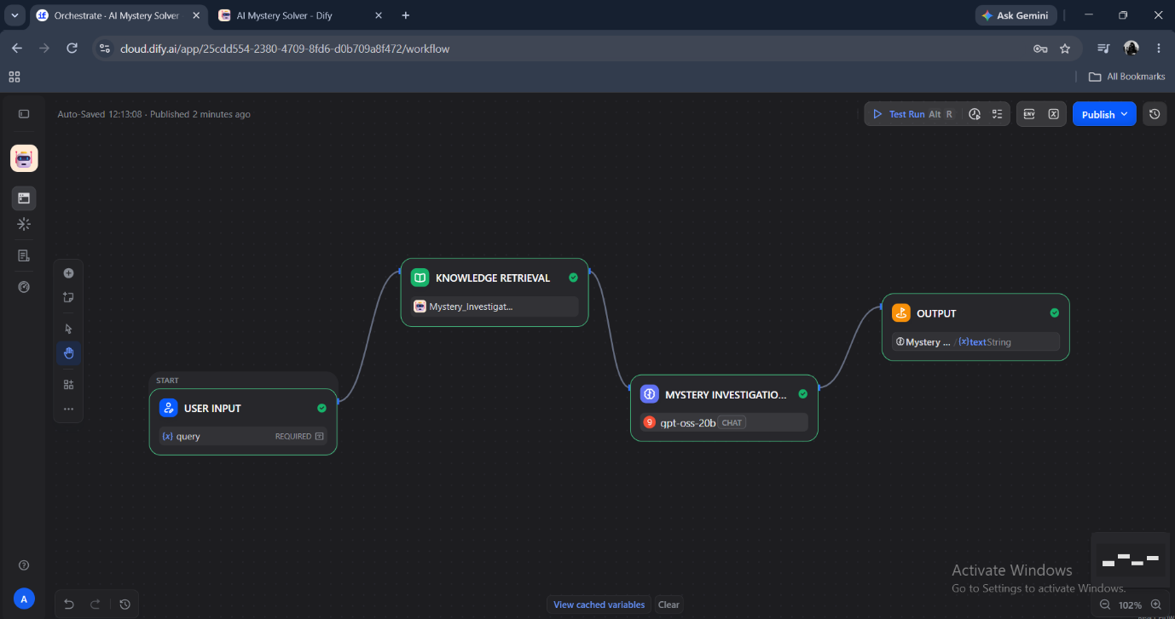
Screenshot 2 – User Input
Explanation:
This screenshot shows the investigation question entered by the user.
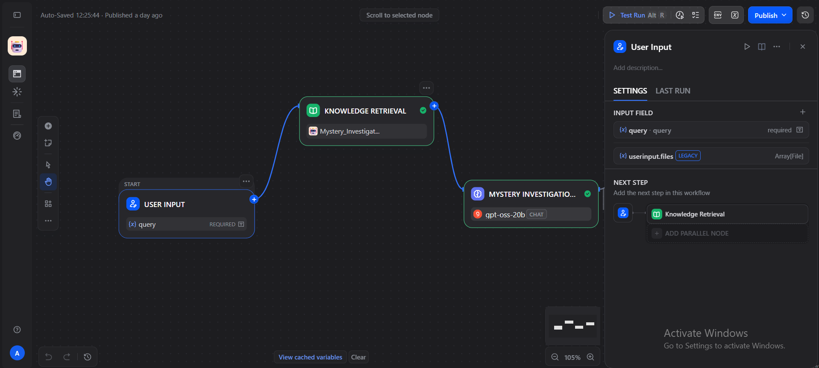
Screenshot 3 – Knowledge Retrieval
Explanation:
This screenshot shows the Knowledge Retrieval node used to retrieve relevant information from the investigation knowledge base.
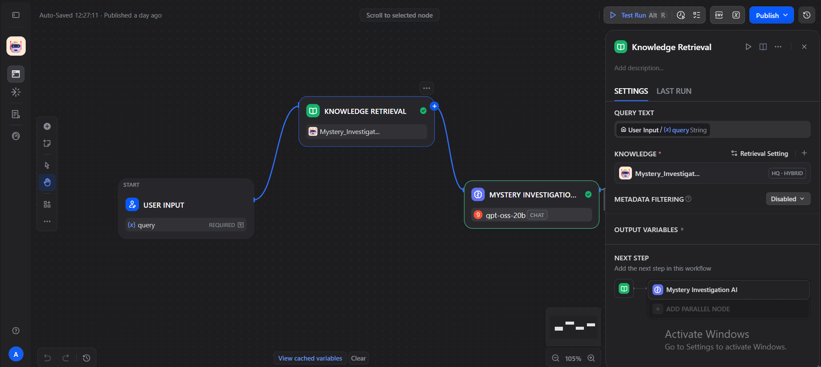

Screenshot 4 – Mystery Investigation AI
Explanation:
This screenshot shows the AI node where the retrieved information is analyzed and used to generate the investigation response.
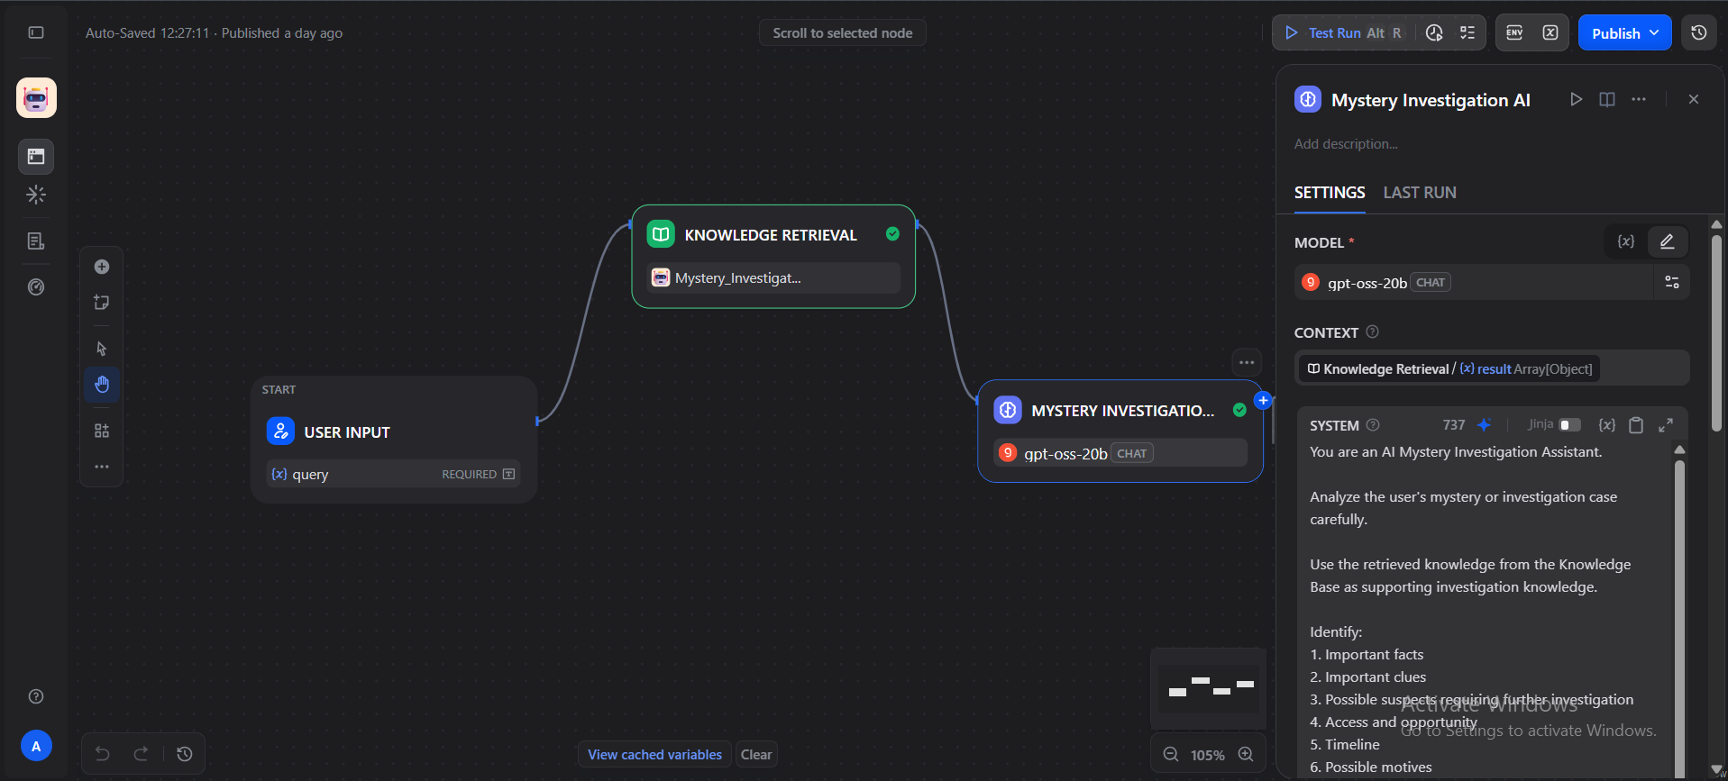
10. Testing & Test Cases :
Test Case | Input | Expected Result
TC01 | Mystery-related question | Relevant investigation response
TC02 | Question about suspects | AI analyzes available information
TC03 | Question about clues | Relevant clues are identified
TC04 | Question based on knowledge base | Knowledge-grounded response
TC05 | General investigation query | Clear AI-generated response
Testing Result
The system was tested using different investigation-related questions. The application successfully retrieved relevant knowledge and generated responses through the AI workflow.
11. Output Screenshots :
Screenshot 1 – Home Screen:
The home screen provides the main interface for the AI Mystery Solver application. It contains a chatbot interface where the user can enter a mystery or investigation-related question.
The interface is designed to provide a simple and user-friendly way for users to interact with the AI Mystery Solver.
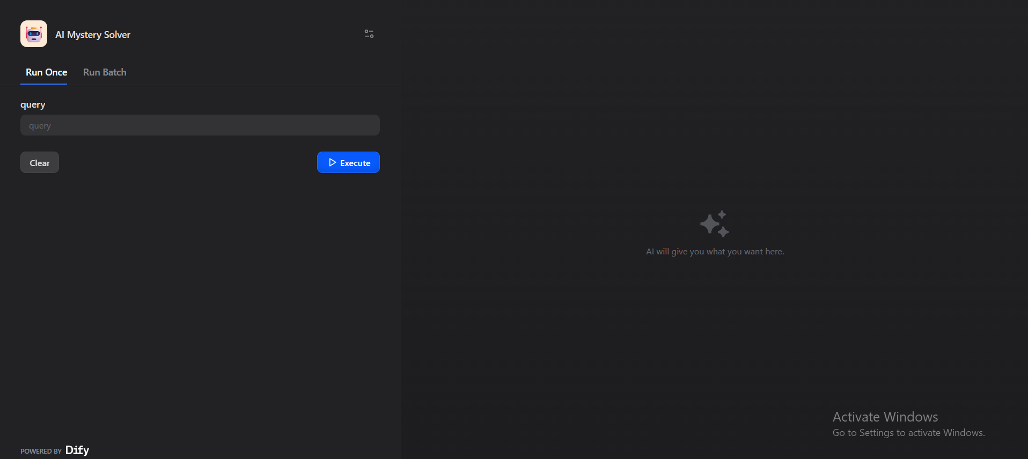
Screenshot 2 – Mystery Question Input:
In this screen, the user enters a mystery-related question into the chatbot input box.
The user can ask questions related to suspects, clues, evidence, or case information. The question is then submitted to the AI Mystery Solver for analysis.

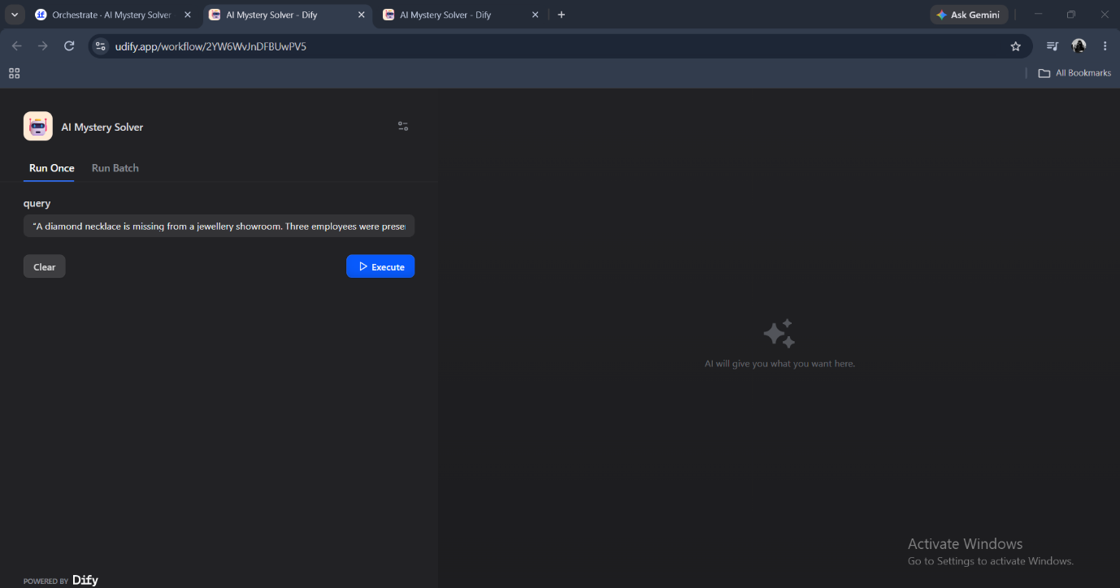
Screenshot 3 – Investigation Result:
After processing the user's question, the AI Mystery Solver generates an investigation response.
The response is based on the relevant information retrieved from the investigation knowledge base using the RAG (Retrieval-Augmented Generation) approach. The AI analyzes the available information and provides a clear response without making unsupported conclusions.
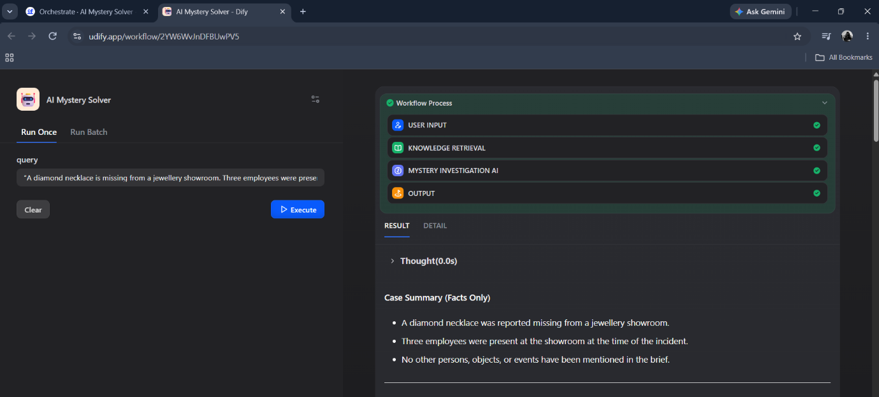

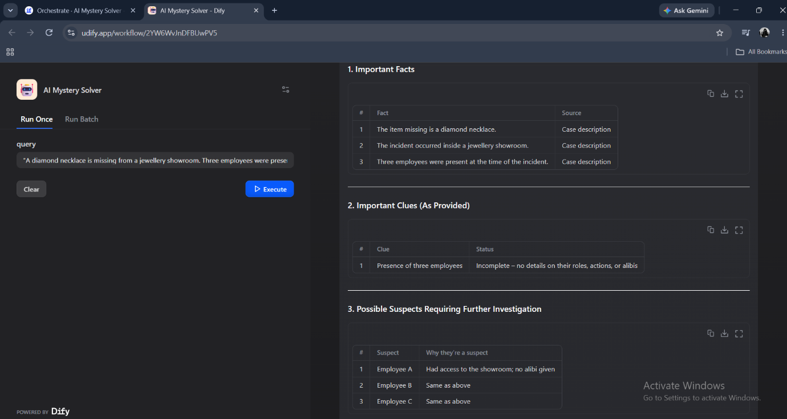
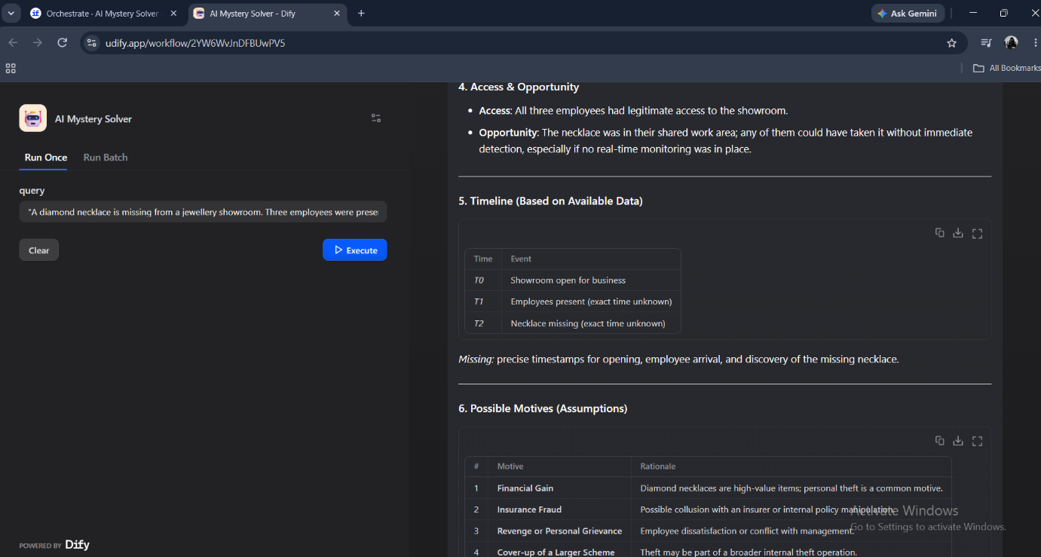
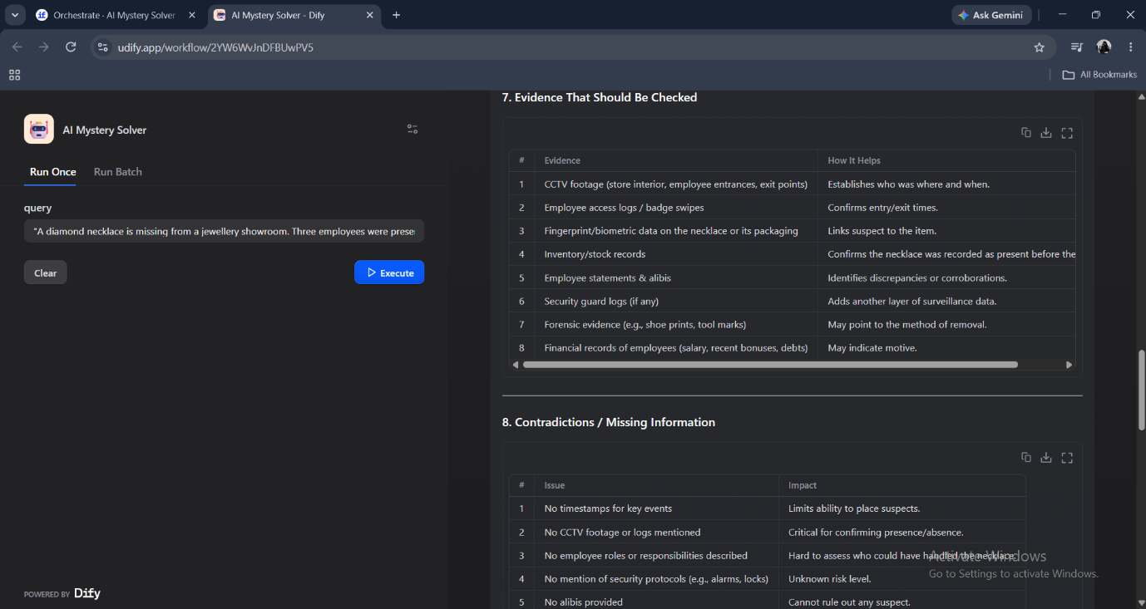

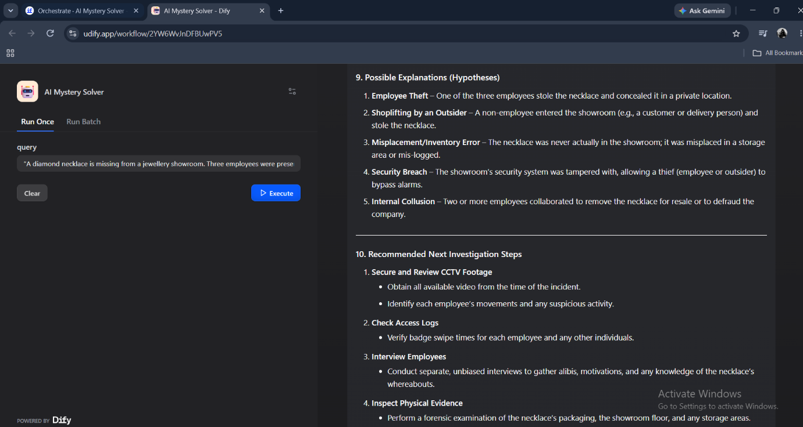

12. Challenges & Solutions, Limitations :
Challenges
- Creating an appropriate investigation knowledge base.
- Connecting Knowledge Retrieval with the AI node.
- Configuring the workflow correctly.
- Ensuring that the AI uses retrieved information.
- Testing different investigation queries.
Solutions
- Created a structured investigation knowledge base.
- Connected Knowledge Retrieval to the AI node.
- Used retrieved context during AI processing.
- Tested the workflow with multiple queries.
- Verified the final output through the Dify application.
Limitations
- Responses depend on the information available in the knowledge base.
- Incorrect or incomplete knowledge may affect the response.
- The system does not replace real-world professional investigation.
- Complex cases may require additional evidence and human analysis.
13. Future Enhancements :
Future versions of the project can include:
- Multiple investigation case files.
- Advanced clue analysis.
- Suspect comparison.
- Evidence relationship analysis.
- Image-based evidence analysis.
- Voice-based investigation queries.
- Case history management.
- Improved AI reasoning capabilities.
- Automatic case report generation.
- Integration with external investigation databases.
14. Conclusion :
Mystery Investigation AI demonstrates the practical use of Generative AI and Retrieval-Augmented Generation (RAG) for investigation-related applications.
The system retrieves relevant information from a knowledge base and provides it to an AI model for analysis. The AI then generates a clear response based on the retrieved context.
The project shows how Dify can be used to build a simple RAG-based AI application without developing the complete AI infrastructure from scratch. It can serve as a foundation for developing more advanced AI-assisted investigation systems.
15. References :
- Dify AI Platform Documentation
- Retrieval-Augmented Generation (RAG) Concepts
- Knowledge Retrieval Documentation
- Large Language Model (LLM) Documentation
- Investigation Knowledge Base Documents
- FacePrep Campus GenAI & LLM Learning Materials

